SECOND ASSIGMENT

Class diagram – Design choices

System
As the users should be able to be both host and guest at the same time, we have created just one class called RegisteredUser, and the system has three lists which are the hosts, guests and both users. This way, the difference between those users will be set on the code, and the users can have any of the three roles.
Non registered users don’t need a class because the limitations on the searches, as well as the other restrictions, are set on the code.
The system has also a method called cancelOffer which is called when the system detects that more than five days have passed since the administrator asked for changes on an offer, and the user has not modified it, or when the start date of a holiday offer has passed and the offer hasn’t been reserved. This method calls denyOffer, which changes the offer status to -2 (we use this function instead of a setter because we may want to add an exaplanation of why the offer is discarded, or to notify the host, for example), and in case the offer is a holiday offer, it is removed from the system. If the offer is a living offer we could just call denyOffer method, but we prefer to use cancelOffer too due to consistency reasons.

House
Currently, the house is composed by the class Characteristic because it’s more visual and, as a result, easier to understand it, but on the actual implementaction we will use a HashMap to do that.

RegisteredUser
The RegisteredUser class has a method addOffer(o: Offer, s: Integer) which allows us to add offers to his bought offers if he is a guest, to his on sale offers list, in case he is a host, or to any of them if he has both roles. We distinguish between the list by using an Integer.
The methods seeHisotry and seeOffers let us visualize the lists of bought and on sale offers previously mentioned.
The integer status shows whether the user is logged in, baned, or none of them, and it is changed my changeStatus method. For example, if the paymentSystem detects a fake credit card, he needs to ban the user, and he uses changeStatus for that.
In case the user is banned, we use changeCreditCard to change his credit card number, and also to change his status to a regular one (logged in or simply registered).

Comments
There are three kinds of comments.
- Text comments: text giving an opinion on an offer or answering another comment.
- Rating: a mark from one to five.
- ChangeComment: a comment made by the administrator to let the host know what he should change if he wants his offer to be approved, or explaining the reason whyhis offer was denied.

Offer
The integer status shows whether the offer is available, denied, reserved, bought, or if it needs some changes.
Once the administrator asks for changes in an offer, he needs to include some text, and a ChangeComment will be created to let the host know what he sould change. Those comments are not visible to any other user.
We have included a lastModifiedDate on the offer in order to know when the offer was changed, denied, reserved (to detect that the user needs to pay), bought, or asked for changes (to detect that the user needs to modify the offer).
The method calculateRating calculates the average rating of the offer using the array of comments it has.

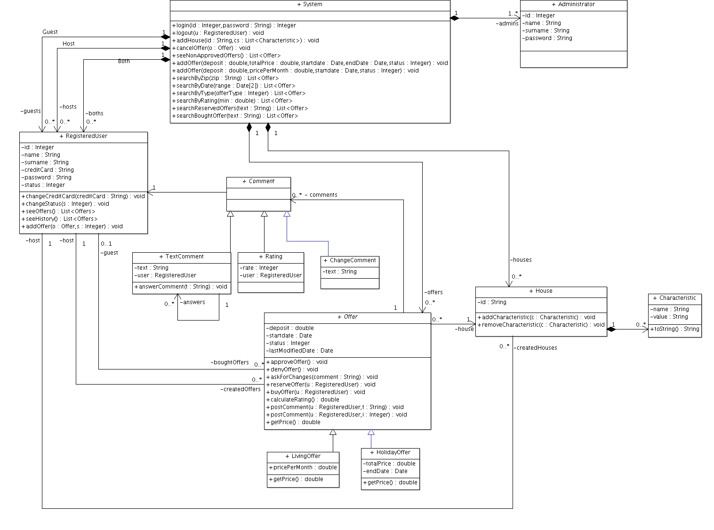

State diagrams

Offer state diagram
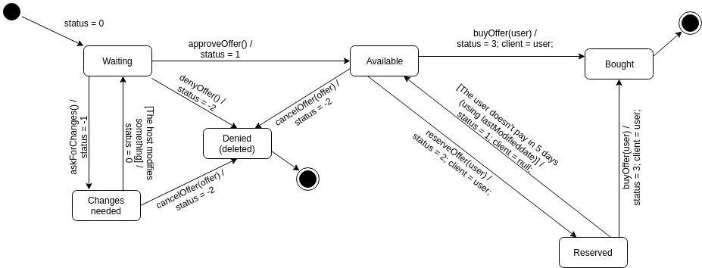

As we don’t really know how this will be implemented in code, we suppose that cancelOffer is called automatically once five days have passed since the changes were asked or once the offer start date passes.

Registered user state diagram

As explained on the user class, changeCreditCard also modifies the user status.
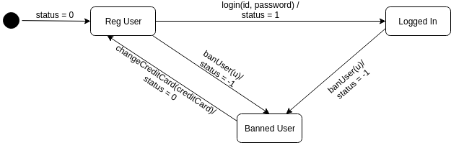

Sequence diagrams

Add house secuence diagram
The function addHouse receives an id and a list of characteristics, and it creates a new house and insert each one of those characteristics to the created house.
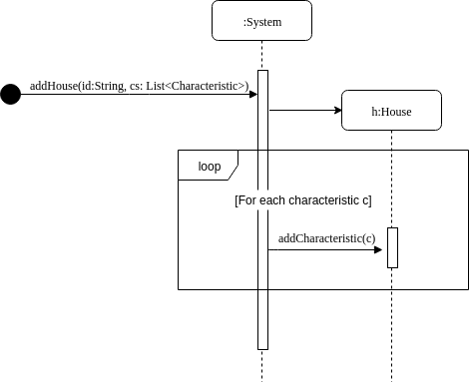

Buy offer sequence diagram
In the offer sequence diagram, the alternatives should be displayed as an alt and an else (as shown below), but as draw.io does not implement this structure, we have just used two alternatives (one for each condition) instead of one.
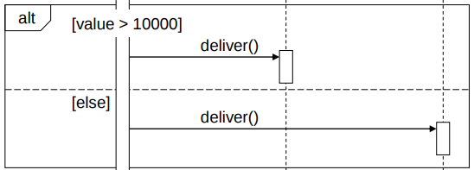

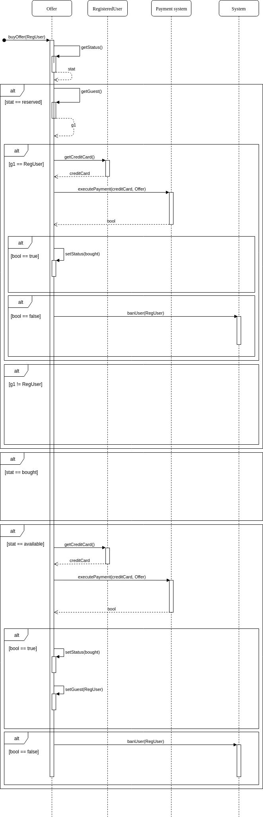

Traceability matrix
In the traceability matrix, the modify offer functional requirement would be also affected by all the offer setters.
As it didn’t fit in a sheet, we have splitted it in two. This first one has all the methods from the system class, and the sencond one includes the methods from the rest of the classes.

